**Small Black Flowers & Leaves Wall Mirror**

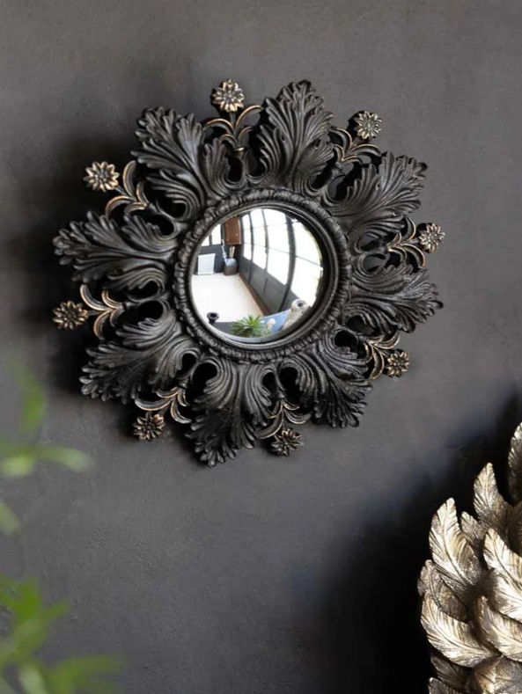The Small Black Flowers & Leaves Wall Mirror is a beautifully crafted piece that combines nature-inspired elegance with modern design. Featuring a delicate frame adorned with black floral and leaf motifs, this mirror exudes a subtle yet sophisticated charm. The intricate details of the flowers and leaves give it a unique and organic feel, while the small size makes it a perfect addition to smaller spaces like entryways, bedrooms, or bathrooms. The black finish adds depth and versatility, making it easy to complement a wide range of interior styles. This mirror serves as both a functional reflection and a striking decorative accent, bringing an element of nature indoors.